ROCKDALE FOUNDATION LOGO| SLEPaN LOGO | ORGANISATION LOGO

REPORT:

SLEPaN Network Employability Skills Boot camp

DATE (Month / Year)

TOWN, COUNTRY

Table of Contents

INTRODUCTION **2**

**PROJECT GOALS** **3**

Short Term Objectives 3

Long-Term Objectives 3

**METHODOLOGY** **4**

Participants 4

Activities 4

**RESULTS** **5**

Case Study 1 5

Case Study 2 5

Survey data 6

LEARNINGS **7**

**SUSTAINABILITY** **7**

# 

# INTRODUCTION

# 

# PROJECT GOALS

## Short Term Objectives

## 

## 

## Long-Term Objectives

# 

# 

# 

# 

# METHODOLOGY

## Participants

## Activities

# RESULTS

## Case Study 1



## Case Study 2



## Survey data



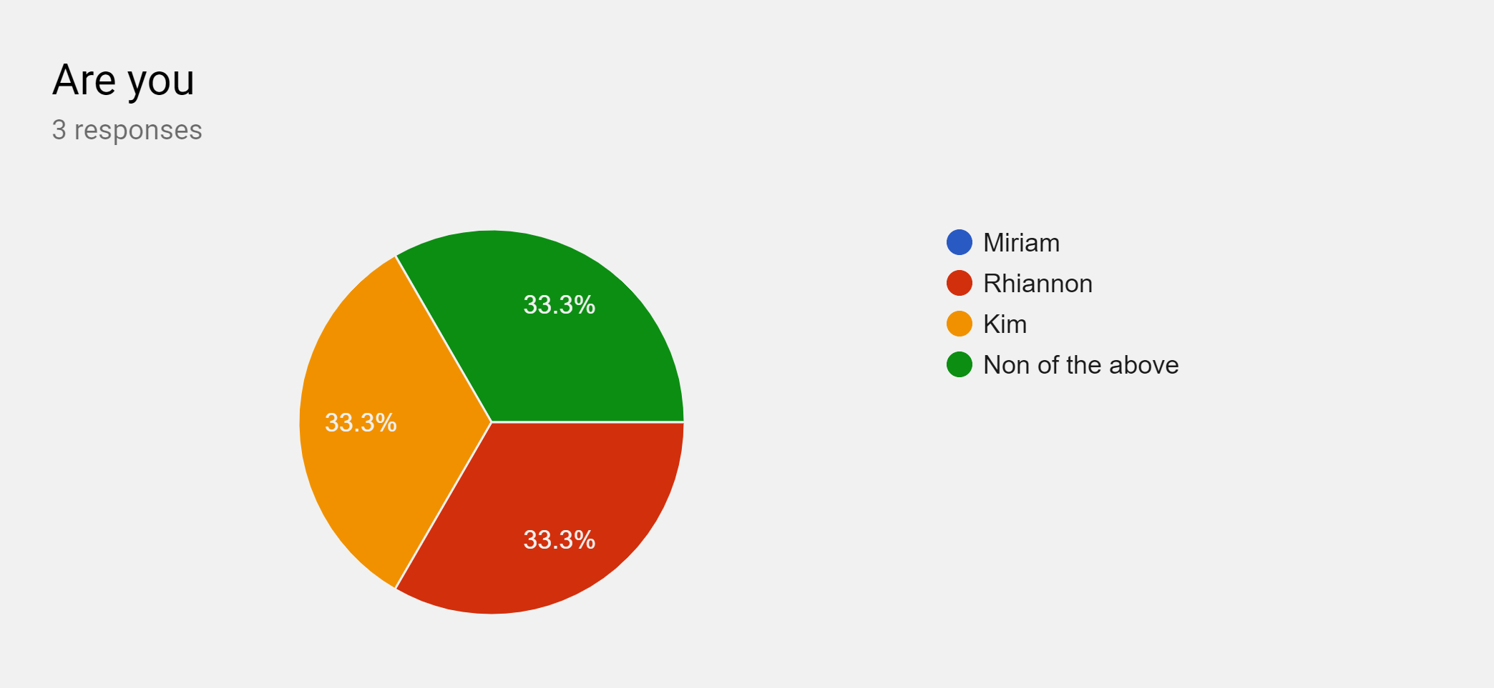

Figure 1: Pie chart showing the percentage of participants named Kim

From surveying all participants at the Employability skills boot camp, we found that one third of them did not have the name Kim, Miriam or Rhiannon. In relation to our proposal, this matches the concept of inclusivity stating that no more than one third of participants should be called Kim.

# LEARNINGS

# SUSTAINABILITY